

University of Petra

System analysis

Done by:  
Ali baddawi

Mousa abu mayaleh

Mohammed abujaber

Kareem hijjawi

Supervised by:

**Dr. nedal nawasra**

Date:

2023-2024  
Summer Semester

**Individual section :**

**1. Introduction: Problem Definition**

The university aims to establish a career center to support students in finding employment opportunities. The center will provide various services such as assistance in CV and cover letter writing, job application completion, and interview preparation. The challenge is to design a system that integrates these services into a website, ensuring easy access and usability for students, while also facilitating interactions between the students, the career center, and potential employers.

**2. Examples of Existing Systems**

Through your web search, you can include the following examples of career center systems:

* **Handshake**  
  URL: <https://joinhandshake.com>  
  Handshake connects students and employers, offering job postings, company research tools, and virtual career fairs. It also helps students with interview preparation and networking.
* **LinkedIn Career Services**  
  URL: <https://www.linkedin.com>  
  LinkedIn provides job search capabilities, professional networking opportunities, and features like a resume builder and interview preparation tools. It also offers personalized job recommendations.
* **WayUp**  
  URL: <https://www.wayup.com>  
  WayUp is a platform tailored to students and recent graduates, offering job and internship listings, job application guides, and interview coaching.

**3. Stakeholders**

The stakeholders for the career center system include:

* **Students**: The primary users who will access the services to improve their job-seeking skills.
* **Career Center Staff**: Administrators who manage the services and assist students.
* **University Management**: They oversee the success of the career center.
* **Employers**: Companies and organizations looking to recruit students.
* **Technical Support Team**: Responsible for maintaining the system's functionality.

**4. Services**

The services that should be included in the system:

* **CV/Resume Writing Assistance**: Templates and guides for creating effective CVs.
* **Cover Letter Writing Help**: Instructions and examples for writing tailored cover letters.
* **Job Application Assistance**: Tools to help fill out job applications.
* **Interview Preparation**: Mock interviews, question guides, and video interview simulations.
* **Job Board**: A platform where students can browse and apply for jobs.
* **Workshops and Webinars**: Schedule and access career development events.

**5. Elicitation Techniques**

Two interactive techniques for collecting requirements are:

* **Joint Application Development (JAD) Sessions**:  
  JAD involves a facilitated session with stakeholders to gather detailed requirements.
  + Questions for JAD:
    1. What specific features do students need from the CV writing service?
    2. How would you prefer to manage interview preparation materials on the website?
    3. What are the most important functionalities employers need to connect with students?
    4. How often should the system update the job postings?
    5. What are your security and privacy concerns for student information?
* **Interviews with Stakeholders**:  
  Conduct one-on-one interviews with various stakeholders to gather insights.
  + Questions for Interviews:
    1. How do students currently apply for jobs, and what challenges do they face?
    2. What type of user interface would be easiest for students to use?
    3. How do you envision integrating workshops and webinars into the system?
    4. What metrics should be tracked to measure the success of the career center?
    5. What technical constraints or resources are available for developing this system?

**6. Conclusion and References**

**Conclusion**: The university’s career center system will serve as a crucial tool to assist students in their job search journey, offering them resources to improve their employability. By incorporating services like CV writing, interview preparation, and job application assistance, the system will bridge the gap between students and potential employers.

**References**:

1. Handshake. Available at: <https://joinhandshake.com>
2. LinkedIn Career Services. Available at: <https://www.linkedin.com>
3. WayUp. Available at: <https://www.wayup.com>

**Group Section :**

**Functional Requirements List**

1. **User Registration and Authentication**
   * **The system shall allow students to register using their university email addresses.**
   * **The system shall require users to create a secure password upon registration.**
   * **The system shall provide login functionality with authentication checks.**
   * **The system shall allow users to reset their passwords if forgotten.**
2. **Profile Management**
   * **The system shall allow students to create and update their profiles, including personal information, academic details, and career interests.**
   * **The system shall enable students to upload their CVs and cover letters to their profiles.**
   * **The system shall allow students to manage the visibility of their profiles to employers and career center staff.**
3. **CV Writing Assistance**
   * **The system shall provide tools and templates for students to create or update their CVs.**
   * **The system shall offer a CV builder with guided steps for creating a professional CV.**
   * **The system shall allow students to download or save their completed CVs in multiple formats (e.g., PDF, Word).**
4. **Cover Letter Writing Assistance**
   * **The system shall provide templates and guidelines for writing cover letters.**
   * **The system shall offer a cover letter builder that allows students to tailor their letters to specific job applications.**
   * **The system shall enable students to download or save their cover letters in multiple formats.**
5. **Job Application Assistance**
   * **The system shall guide students through the process of filling out job applications.**
   * **The system shall allow students to save and manage multiple job applications within their profiles.**
   * **The system shall provide reminders and alerts for application deadlines.**
6. **Interview Preparation**
   * **The system shall provide resources such as common interview questions and best practices.**
   * **The system shall offer interactive mock interview sessions, either through the platform or with career advisors.**
   * **The system shall provide feedback on mock interviews, highlighting areas of improvement.**
7. **Job Search and Matching**
   * **The system shall offer a job search feature, allowing students to search for jobs based on criteria such as location, industry, and job type.**
   * **The system shall match students with relevant job opportunities based on their profiles and preferences.**
   * **The system shall notify students of new job postings that match their criteria.**
8. **Employer Portal**
   * **The system shall allow employers to register and create profiles on the platform.**
   * **The system shall enable employers to post job openings and internships.**
   * **The system shall allow employers to search for and view student profiles and CVs, based on the students' privacy settings.**
   * **The system shall allow employers to contact students directly through the platform.**
9. **Communication and Support**
   * **The system shall provide a messaging feature for students to communicate with career advisors and employers.**
   * **The system shall offer a support feature where students can submit queries or request assistance.**
   * **The system shall provide a FAQ section to address common issues and questions.**
10. **Reporting and Analytics**
    * **The system shall generate reports on student engagement, job application success rates, and other key metrics for career center staff.**
    * **The system shall provide analytics dashboards to help career center staff monitor the effectiveness of the services offered.**

**Context Diagram**

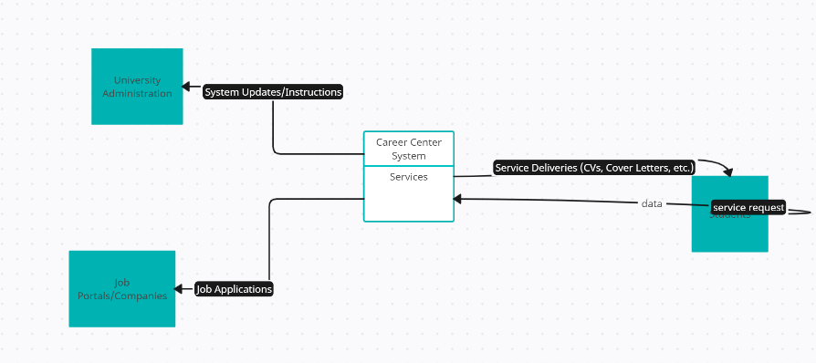

**Diagram 0**

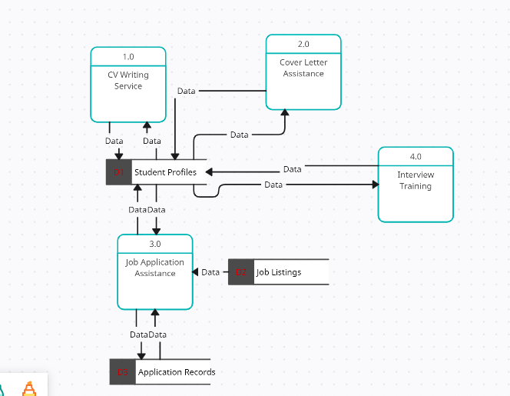

**1.0 Process (CV Writing Service)**

**2.0 Cover Letter Assistance**

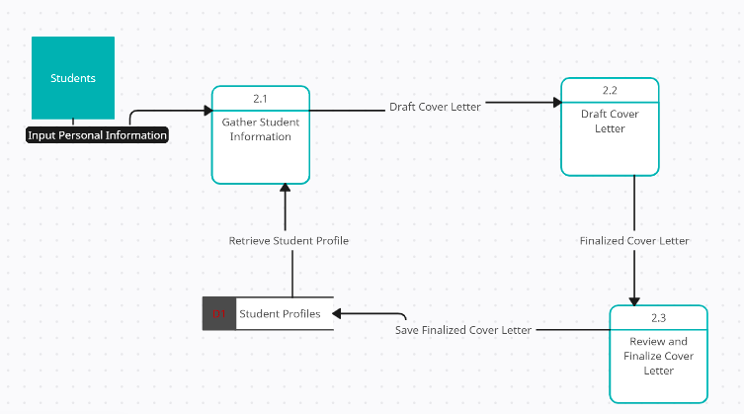

**3.0 Process (Job Application Assistance)**

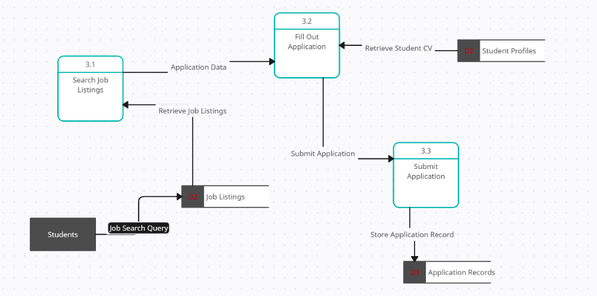

**4.0 Interview Training**

**1. Context Diagram of DFD Model**

* **The context diagram is the highest level of the DFD and represents the entire system as a single process, interacting with external entities.**
* **Entities:**
  + **Students: Interact with the Career Center System to avail services.**
  + **Job Portals/Companies: Receive applications from the Career Center.**
  + **University Administration: Manages and oversees the Career Center operations.**
* **Process:**
  + **Career Center System: The central system that provides services to students, such as CV writing, cover letter preparation, job application assistance, and interview training.**
* **Data Flows:**
  + **From Students to Career Center System: Service Requests.**
  + **From Career Center System to Students: Service Deliveries (CVs, Cover Letters, etc.).**
  + **From Career Center System to Job Portals/Companies: Job Applications.**
  + **From University Administration to Career Center System: System Updates/Instructions.**

**2. Diagram 0**

* **Diagram 0 is a more detailed view of the context diagram, breaking down the main process (Career Center System) into its sub-processes.**
* **Processes:** 
  + **1.0 CV Writing Service: Helps students draft and format their CVs.**
  + **2.0 Cover Letter Assistance: Guides students in writing effective cover letters.**
  + **3.0 Job Application Assistance: Helps students fill out job applications and submit them.**
  + **4.0 Interview Training: Provides interview preparation and mock interviews.**
* **Data Stores:** 
  + **D1 Student Profiles: Stores student information, including personal details, CVs, and cover letters.**
  + **D2 Job Listings: Stores information about available job opportunities.**
  + **D3 Application Records: Keeps a record of submitted job applications.**
* **Data Flows:** 
  + **Between processes and data stores to represent the flow of information.**

**3. Two Child Diagrams of Any Non-Primitive Process in Diagram 0**

* **For CV Writing Service:** 
  + **1.1 Gather Student Information**
  + **1.2 Draft CV**
  + **1.3 Review and Finalize CV**
* **For Job Application Assistance:** 
  + **3.1 Search Job Listings**
  + **3.2 Fill Out Application**
  + **3.3 Submit Application**

**4. Description of Two Data Stores in DFD (Data Dictionary)**

* **D1 Student Profiles:** 
  + **Name: Student Profiles**
  + **Description: Stores personal information of students including their CVs and cover letters.**
  + **Attributes: Student ID, Name, Contact Information, CV, Cover Letter.**
* **D2 Job Listings:** 
  + **Name: Job Listings**
  + **Description: Contains information about job opportunities from various companies.**
  + **Attributes: Job ID, Company Name, Job Title, Job Description, Requirements, Application Deadline.**

**5. Description of Two Data Structures in DFD (Data Dictionary)**

* **Student Profile Structure:** 
  + **Attributes:** 
    - **Student ID: Unique identifier for each student.**
    - **Name: Full name of the student.**
    - **Contact Information: Email, phone number, address.**
    - **CV: The student's resume in a standard format.**
    - **Cover Letter: Personalized cover letter for job applications.**
* **Job Listing Structure:** 
  + **Attributes:** 
    - **Job ID: Unique identifier for each job listing.**
    - **Company Name: Name of the company offering the job.**
    - **Job Title: The title of the job position.**
    - **Job Description: Detailed description of job responsibilities.**
    - **Requirements: List of qualifications and skills required for the job.**

**6. Description of Three Data Flows in Your DFD (Data Dictionary)**

* **Service Request:** 
  + **Source: Student**
  + **Destination: Career Center System**
  + **Description: Request for services like CV writing, cover letter preparation, or job application assistance.**
* **Service Delivery:** 
  + **Source: Career Center System**
  + **Destination: Student**
  + **Description: Completed service such as a drafted CV or cover letter.**
* **Job Application:** 
  + **Source: Career Center System**
  + **Destination: Job Portals/Companies**
  + **Description: The finalized job application submitted on behalf of the student.**

**7. Description of Three Data Elements in Your DFD (Data Dictionary)**

* **Student ID:** 
  + **Type: Integer**
  + **Description: A unique identifier for each student in the system.**
* **Job Title:** 
  + **Type: String**
  + **Description: The title of the job position listed in the job postings.**
* **CV:** 
  + **Type: Document**
  + **Description: A digital document containing the student’s resume, formatted and reviewed by the career center.**